❖ Components Required

# Aduino Nano

The **Arduino Nano** is a small, complete, and breadboard-friendly [board](https://en.wikipedia.org/wiki/Single-board_microcontroller) based on the [ATmega328P](https://en.wikipedia.org/wiki/ATmega328) released in 2008. It offers the same connectivity and specs of the [Arduino Uno](https://en.wikipedia.org/wiki/Arduino_Uno) board in a smaller form factor.

The Arduino Nano is equipped with 30 male [I/O](https://en.wikipedia.org/wiki/I/O) headers, in [a DIP-30-](https://en.wikipedia.org/wiki/Dual_in-line_package)like configuration, which can be programmed using the [Arduino](https://en.wikipedia.org/wiki/Arduino) Software [integrated development environment](https://en.wikipedia.org/wiki/Integrated_development_environment) (IDE), which is common to all Arduino boards and running both online and offline. The board can be powered through [a type-B mini-USB](https://en.wikipedia.org/wiki/USB_hardware#Connectors) cable or from a 9 V battery.

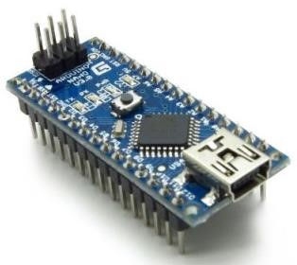

## Specifications:-

* Microcontroller Atmel ATmega328 SMD Package
* Operating Voltage (logic level) 5 V
* Input Voltage (recommended) 7-12 V
* Input Voltage (limits) 6-20 V
* Digital I/O Pins 14 (of which 6 provide PWM output)
* Analog Input Pins 8
* DC Current per I/O Pin 40 mA
* Flash Memory 32 KB (of which 2KB used by bootloader)
* SRAM 2 KB
* EEPROM 1 KB
* Clock Speed 16 MHz
* Dimensions 0.70” x 1.70”

# SIM900A or SIM 800L

SIM900A Modem is built with Dual Band GSM based SIM900A modem from SIMCOM. It works on frequencies 900MHz. SIM900A can search these two bands automatically. The frequency bands can also be set by AT Commands. The baud rate is configurable from 1200-115200 through AT command. SIM900A is an ultra compact and wireless module. The Modem is coming interface, which allows you connect PC as well as microcontroller with RS232 Chip(MAX232). It is suitable for SMS, Voice as well as DATA transfer application in M2M interface. The onboard Regulated Power supply allows you to connect wide range unregulated power supply. Using this modem, you can make audio calls, SMS, Read SMS, attend the incoming calls and ect. through simple AT commands. This is a complete GSM module in a SMT type and made with a very powerful single-chip, allowing you to benefit from small dimensions. SIM 900A GSM Modem with serial and TTL outputs.

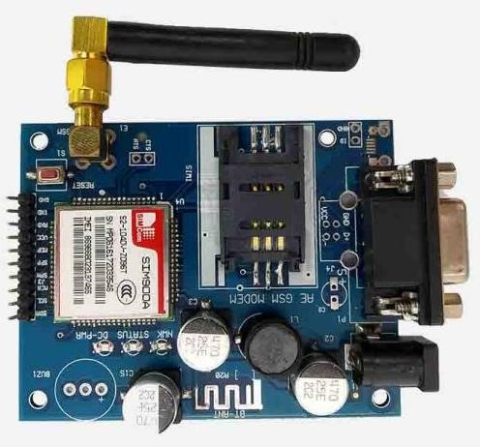

## Features:-

* Quad-Band GSM/ 850/900/1800/1900MHz
* Compatible with arduino, raspberry pi, arm, avr, pic, 8051
* power supply 12v 1amp to 2 amps max • Use in the area of full signal strength.
* Perfect suited for GSM based Microcontroller Projects (better than SIM300 and other GSM Modems)
* Option for connecting MIC and SPEAKER directly to GSM MODEM for calls (LINE IN also available)
* Supports communication through RS232 with DB9 Connector, TTL Pins and I2C Pins
* CALL SMS GPRS facility - MIC input, LINE input and SPEAKER output pins

# Load Cell Half Bridge

The 50kg Half-bridge Experiments Body Scale Load Cell Sensor is measuring; the correct force is applied to the outer side of the strain E-shaped beam portion of the sensor (i.e., a strain gauge affixed to the intermediate, adhesive coating with white beam arms); and the outer edges to form a shear force in the opposite direction, i.e., middle strain beam bending necessary changes can occur under stress, strain beam side by another force should not be a barrier.

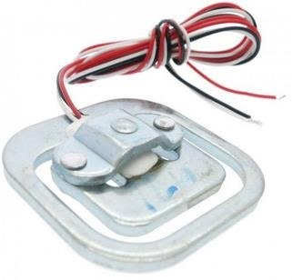

**The sensor can be used with the following three methods:-**

1. Using a sensor with an external resistors full bridge measurement range of a sensor range: 50kg. Higher requirements for an external resistor.
2. The uses of only two full-bridge sensors measuring range are the range of the two sensors and: 50kgx2 = 100kg.
3. The use of four full-bridge sensors measuring range is the range of four sensors and: 50kgx4 = 200kg.

## Features of 50kg Half-bridge Experiments Body Scale Load Cell Sensor:-

1. Internal 1000Ohm half-bridge strain gauge load cell, the range is 50kg, half-bridge structure.
2. Widely used in hopper scales, platform scales, platform balance, belt scales, and other electronic weighing devices.
3. This is a half-bridge load sensor, which is widely used in weight scales. When the half-bridge is being stretched, it sends the signal via the red signal wire. 4. Alloy Steel wired weighing load cell, high accuracy, simple structure, simple installation.

You can use multiple load sensors simultaneously to increase the capacity range, Parallel use to add additional capacity.

## Specifications of 50kg Half-bridge Experiments Body Scale Load Cell Sensor:-

Capacity (Kg) 50

Output Sensitivity (mv/v)1 0.1

Nonlinearity (%FS) 0.03

Repeatability (%FS) 0.03

Input Resistance () 1000

Insulation Resistance (M) 5000

Cable Length (cm) 35

Length (mm) 34

|  |  |
| --- | --- |
| Width (mm) | 34 |
| Height (mm) | 8 |
| Weight (gm) | 20 |

# HX711

HX711 module is a Load Cell Amplifier breakout board for the HX711 IC that allows you to easily read load cells to measure weight. This module uses 24 high precision A/D converter chip HX711. It is a specially designed for the high precision electronic scale design, with two analog input channel, the internal integration of 128 times the programmable gain amplifier. The input circuit can be configured to provide a bridge type pressure bridge (such as pressure, weighing sensor mode), is of high precision, low cost is an ideal sampling front-end module.

HX711 is an IC that allows you to easily integrate load cell into your project. No need of any amplifiers or dual power supply just use this board and you can easily interface it to any micro-controller to measure weight.

The HX711 uses a two wire interface (Clock and Data) for communication. Compared with other chips, HX711 has added advantages such as high integration, fast response, immunity, and other features improving the total performance and reliability. Finally it's one among the best choices for electronic enthusiasts. The chip lowers the cost of the electronic scale,at the same time,improving performance and reliability.

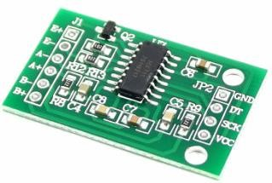

## Specifications:-

* Differential input voltage: ±40mV (Full-scale differential input voltage is ± 40mV)
* Data accuracy: 24 bit (24 bit A / D converter chip.)
* Refresh frequency: 10/80 Hz
* Operating Voltage: 2.7V to 5VDC
* Operating current: <10 mA
* Size: 24x16mm

# Vibration Motor

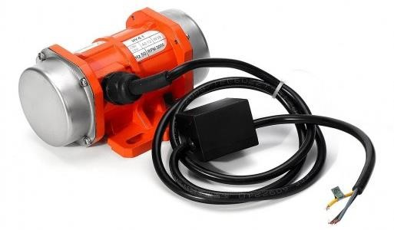

# ADXL335

ADXL335 is a Breakout board based on 3 axis ADXL335 IC from Analog Devices. The Accelerometer Module require no external devices and works on 5V power supply. It can be directly interfaced to ADC of a microcontroller without any external components.

This module can be used to sense motion or tilt(in case of non moving) in 3 axis.This is the latest in a long, proven line of Analog Sensors- the holy grail of accelerometers. The ADXL335 is a triple axis MEMS accelerometer with extremely low noise and power consumption - only 320uA! The sensor has a full sensing range of +/-3g The burst echo to return to the sensor. By measuring the echo pulse width, the distance to target can easily be calculated.

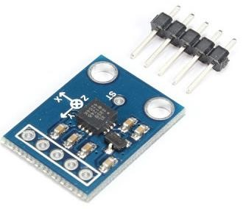

**Features of ADXL335:**

* 3-axis sensing.
* Small, low profile package.
* 4 mm × 4 mm × 1.45 mm LFCSP.
* Low power : 350 μA (typical).
* Single-supply operation: 1.8 V to 3.6 V.
* 10,000 g shock survival.
* Excellent temperature stability.
* BW adjustment with a single capacitor per axis.
* RoHS/WEEE lead-free compliant.

**Applications of ADXL335:**

* Cost sensitive, low power, motion- and tilt-sensing applications.
* Mobile devices.
* Gaming systems.
* DIY projects requiring orientation information.

# Level Sensor (Ultrasonic Sensor)

It is an ultrasonic sensor module based on the CS100, an industrial-grade ultrasonic distance measurement chip. This chip integrates ultrasonic transmitter, ultrasonic receiver, and digital processing circuits. The distance measurement result output is in the form of pulse width. For an ultrasonic detector, there are two main parts: Emitter and Detector. The emitter transmits an ultrasonic sound wave, and the detector receives back the signal from the emitter reflected by an object. By calculating the travel time and the speed of sound, the distance of the object can be determined.

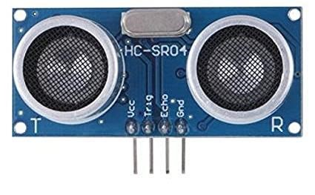

## Features:-

* The new version of HC-SR04 has far more performance than the old version of HC-

SR04 and US-015. In the case of higher ranging accuracy than the old versions of HC-SR04 and US-015, the ranging range is farther, up to 6 meters. Far more than the general ultrasonic ranging module.

* Adopt CS-100 ultrasonic ranging SOC chip, high performance, industrial grade, wide voltage, low price,; and the performance far exceeds the ordinary ultrasonic ranging module.
* HC-SR04 ultrasonic ranging module can realize non-contact ranging function of 2cm~6m, working voltage is 3V-5.5V, working current is 5.3mA, support GPIO communication mode, work is stable and reliable.
* The new HC-SR04 is the same size as the old HC-SR04, and the interface is fully compatible; but the distance measurement is longer, the accuracy is higher, the working voltage is wider, and it is industrial grade.
* The performance is the same as that of US-025 and US-026. Both adopt CS100 chip and the interface is fully compatible.

## Specifications:-

* Ultrasonic distance measuring chip: CS100
* Working voltage: DC 3V-5.5V
* Working current: 5.3mA
* Working temperature: -40 ° C -85 ° C
* Output method: GPIO
* Induction angle: less than 15 degrees
* Detection distance: 2cm-600cm
* Detection accuracy: 0.1cm+1%

# Load Cell

**Level Sensor**

**Control Unit**

**Load Cell**

**Vibrating Motor**

**Projection**

**Screen**

**Camera**

**Accident**

**Detection**

**GSM**

**Module**